**PROJECT DEVELOPMENT PHASE**

**SPRINT-2**

**WATSON IOT**

|  |  |
| --- | --- |
| Date | 15 November 2022 |
| Team ID | PNT2022TMID31875 |
| Project Name | IoT Based Safety Gadget for Child Safety Monitoring and Notification |
| Maximum Marks | 1. Marks |

**AIM:**

To connect tracking device or manually programmed python code to IBM Watson IoT Platform.

**Source Code:**

import random as rand

import time

import ibmiotf.application

import ibmiotf.device

import sys

import imdb

#defining credentials of device

organization = "aa13kc"

deviceType = "Vijay2001"

deviceId = "1234567"

authMethod = "token"

authToken = "Yd-6ozY-S6BLhM0vkw"

def myCommandCallback(cmd):

print("Command received: %s" % cmd.data['command'])

try:

deviceOptions = {"org" : organization, "type": deviceType, "id" : deviceId, "auth-method" : authMethod, "auth-token" : authToken}

deviceCli = ibmiotf.device.Client(deviceOptions)

except Exception as e:

print("Caught exception connecting device: %s" %str(e))

sys.exit()

deviceCli.connect()

while True:

name= "Vijay2001"

lat= 10.908532

lon= 76.979312

#Manually sending the coordintes

data = {'name':name,'Latitude' : lat,

'Longitude': lon}

def myOnPublishCallback():

print("Published all data to IBM Watson :",lat," ,",lon)

success = deviceCli.publishEvent("Iottracker","json",data,qos=0,on_publish=myOnPublishCallback)

if not success:

print("Not connected to IoT Device")

time.sleep(5)

deviceCli.commandCallback = myCommandCallback

deviceCli.disconnect()

**Program output:**

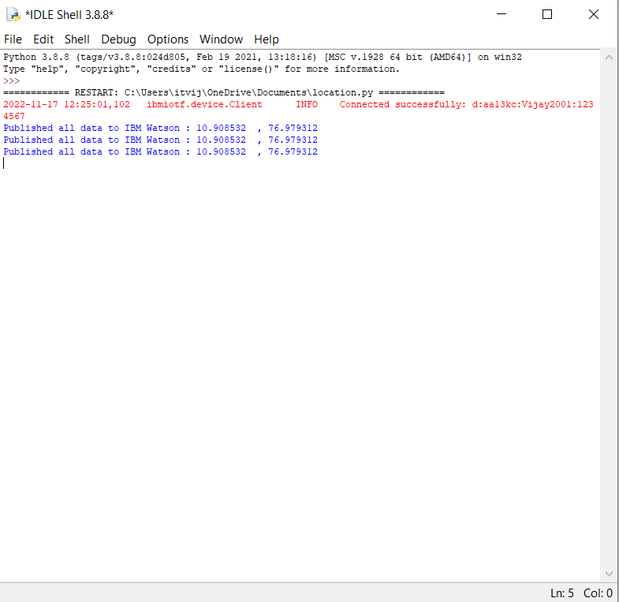

**IBM Watson IoT:**

* Device connected to IBM Watson IoT Platform.

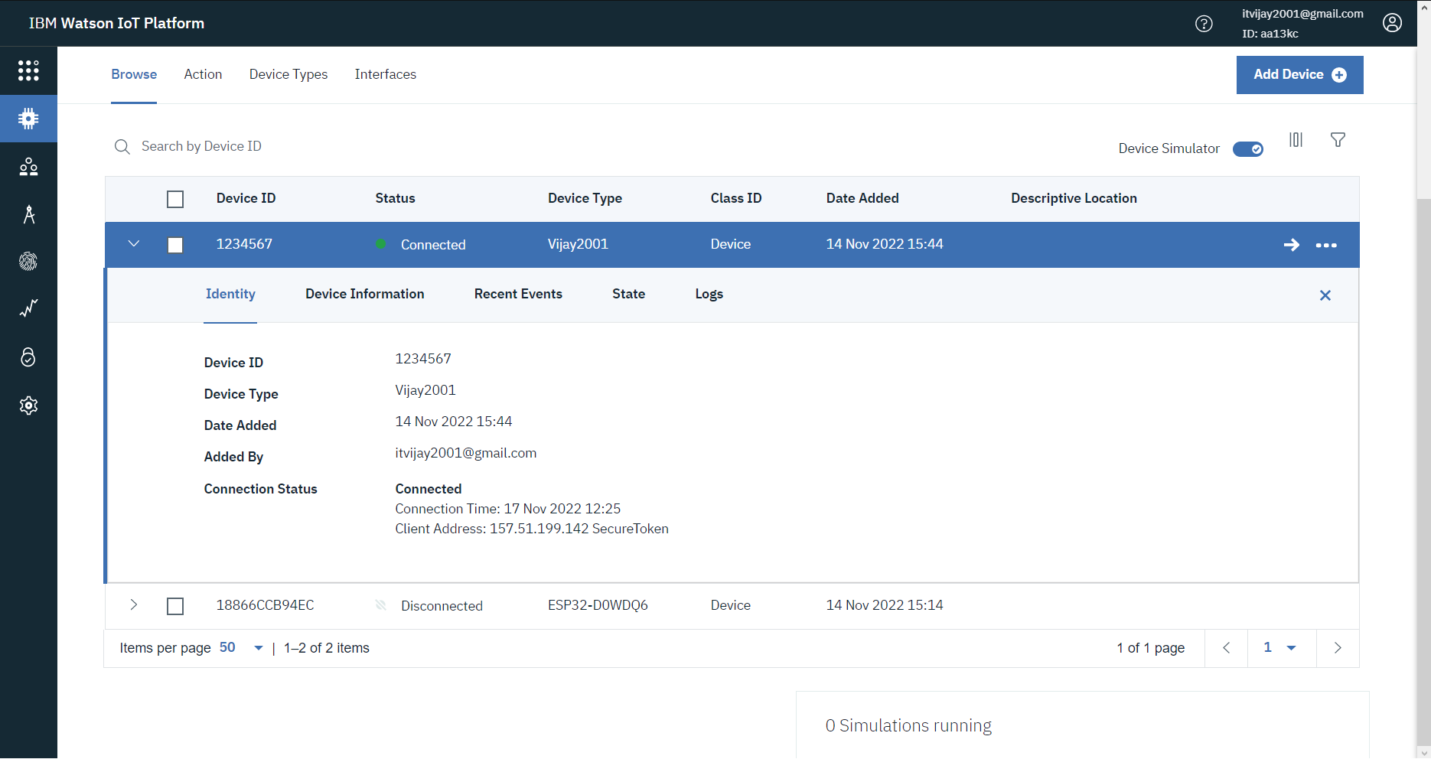

* Getting coordinates as output in IBM Watson IoT Platform.

